**Database Management System**

**(Lab Task No 05)**



Session (2022-2026)

Program/Class

**BS-Computer Science / 5rd Section-A**

Submitted By:

Student Name: Shaheer Ali Roll Number: 301-221044

Supervised By:

Ms. Muneeba Darwaish

Lecturer

CS& IT Department

**Hazara University, Mansehra**

**Showing Table:**

First of all I have shown the table that I have created in my database,

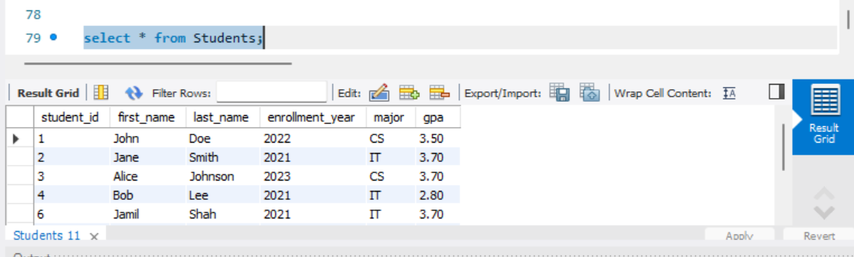

**Using OR Query:**

I have used the **OR** query to find the student record with gpa= 3.5 and major = ‘CS’.

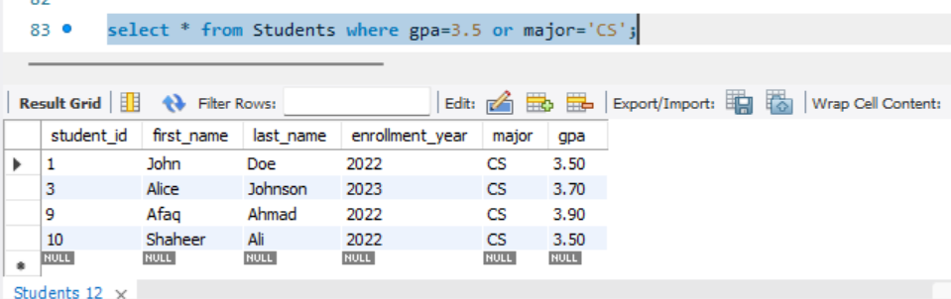

**Using ‘AND’ Query:**

I have used the and query to show records with 3.5 in computer science department,

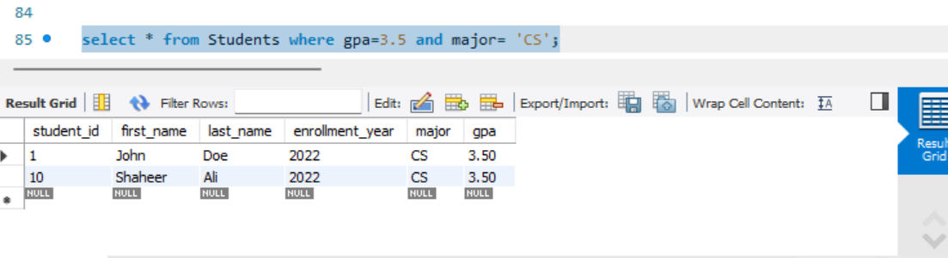

**Using UPDATE Query:**

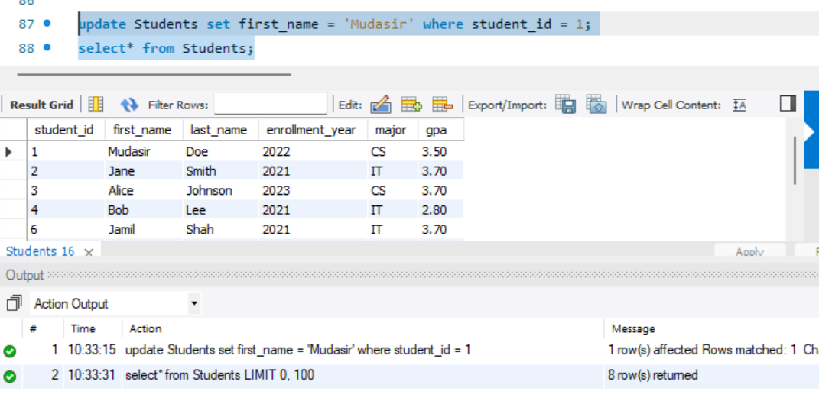

**Using Delete Query:**

I have deleted student_id no 4 , in the table Students, with the help of Delelet Command

